1. 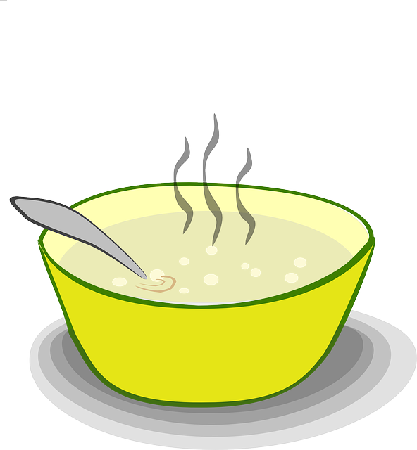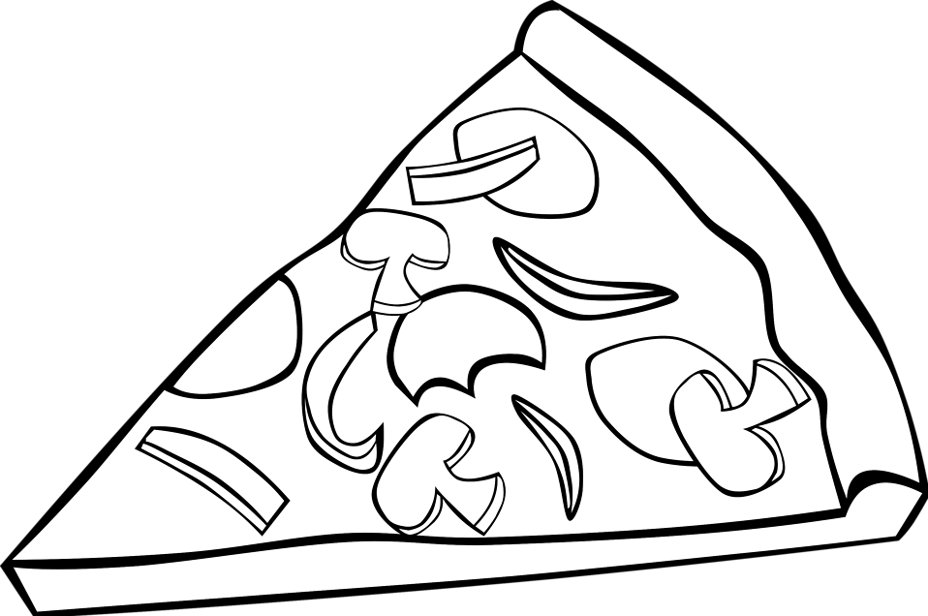Homework Menu: April 20-24, 2020

Spelling List

Homophones

Spelling Words

1. don’t
2. didn’t
3. it’s
4. isn’t
5. can’t
6. they’re
7. couldn’t
8. wouldn’t
9. shouldn’t
10. doesn’t

Appetizer (2)

__ iReady Math: Complete at least 20 minutes of math iReady

___iReady Reading: Complete at least 20 minutes of reading iReady

___ Spelling City: Practice your spelling words at <https://www.spellingcity.com/users/ctw1>

___ Creative spelling: Practice your spelling words any way you want (chalk, paint, in the bathtub, type on the computer, etc.)

___Practice counting back starting from any number between 30 and 120.

Entree (2)

___Write sentences with each of your spelling words.

___Rhyming Words: Write each spelling word and a rhyming word next to it.

___ Practice writing your numbers from 100-150.

___ Write a story with all of your spelling words.



Dessert (2)

___ Play outside for 20 minutes.

___ Play a game to practice math skills.

___ Play a game to practice reading skills.

___ Show off your reading skills! Practice reading a book or poem. Then call someone and read it to them.

**Daily Reading Response**

*Read a book with a grownup. Ask and answer a question about the beginning, middle, and end of the book. We are working on who, what, when, where, why questions. You do not need to write the questions and answers. Record the title of the book below.*

**Monday ________________________**

**Tuesday ________________________**

**Wednesday ________________________**

**Thursday**

**________________________**